SET 28
Vehicle Performance Analysis
Dataset
Vehicle_ID | Engine_Size (L) | Horsepower | Fuel_Efficiency (km/l) | Top_Speed (km/h) | Safety_Rating
V1 | 1.5 | 110 | 18 | 180 | 4
V2 | 2.0 | 150 | 15 | 200 | 5
V3 | 3.0 | 250 | 12 | 250 | 5
V4 | 2.5 | 200 | 14 | 220 | 4
V5 | 1.8 | 130 | 17 | 190 | 3

1. Violin plot of fuel efficiency by safety rating
R Code

library(ggplot2)

vehicle <- data.frame(
Vehicle_ID = c("V1", "V2", "V3", "V4", "V5"),
Engine_Size = c(1.5, 2.0, 3.0, 2.5, 1.8),
Horsepower = c(110, 150, 250, 200, 130),
Fuel_Efficiency = c(18, 15, 12, 14, 17),
Top_Speed = c(180, 200, 250, 220, 190),
Safety_Rating = c(4, 5, 5, 4, 3)
)

ggplot(vehicle, aes(
x = factor(Safety_Rating),
y = Fuel_Efficiency,
fill = factor(Safety_Rating)
)) +
geom_violin(trim = FALSE) +
geom_jitter(width = 0.08, size = 3) +
labs(
title = "Fuel Efficiency by Safety Rating",
x = "Safety Rating",
y = "Fuel Efficiency (km/l)",
fill = "Safety Rating"
) +
theme_minimal()
Output:
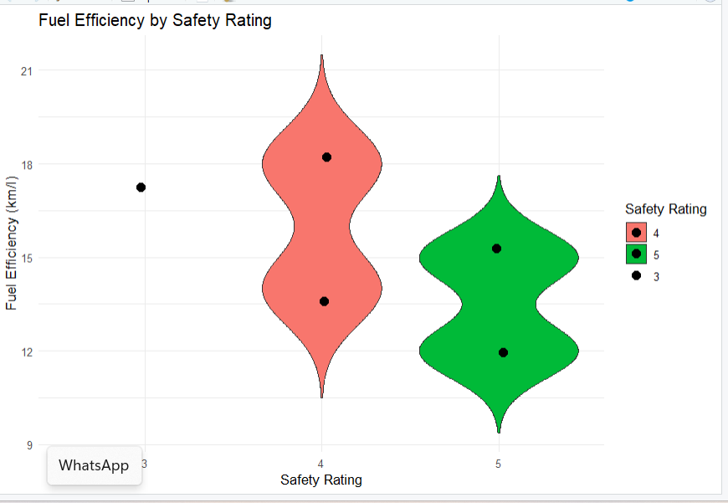
Result: Rating 4 vehicles have efficiencies of 18 and 14 km/l, while rating 5 vehicles have 15 and 12 km/l. Rating 3 has only one vehicle, V5, at 17 km/l. With just five vehicles, the violin shapes and variability estimates are unreliable; the points show the actual observations more clearly.

2. Scatter plot of horsepower and top speed
R Code

ggplot(vehicle, aes(
x = Horsepower,
y = Top_Speed,
color = Engine_Size
)) +
geom_point(size = 4) +
geom_smooth(method = "lm", se = FALSE, color = "black") +
scale_color_gradient(low = "blue", high = "red") +
labs(
title = "Horsepower vs Top Speed",
x = "Horsepower",
y = "Top Speed (km/h)",
color = "Engine Size (L)"
) +
theme_minimal()

cor(vehicle$Horsepower, vehicle$Top_Speed)

Output:
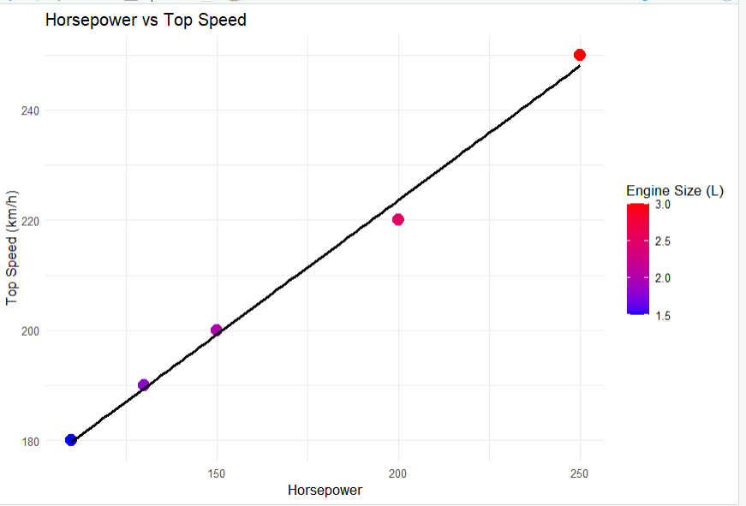
Result: Horsepower and top speed have a very strong positive correlation (approximately 0.99). Vehicles with higher horsepower and larger engines tend to have higher top speeds in this dataset.

3. Correlation heatmap of numerical variables
R Code

library(ggplot2)
library(tidyr)

numeric_data <- vehicle[, c(
"Engine_Size", "Horsepower", "Fuel_Efficiency",
"Top_Speed", "Safety_Rating"
)]

cor_matrix <- cor(numeric_data)

cor_long <- as.data.frame(as.table(cor_matrix))
names(cor_long) <- c("Variable1", "Variable2", "Correlation")

ggplot(cor_long, aes(
x = Variable1,
y = Variable2,
fill = Correlation
)) +
geom_tile(color = "white") +
geom_text(aes(label = round(Correlation, 2)), size = 3.5) +
scale_fill_gradient2(
low = "blue", mid = "white", high = "red",
midpoint = 0, limits = c(-1, 1)
) +
labs(
title = "Vehicle Performance Correlation Heatmap",
x = "Numerical Variables",
y = "Numerical Variables",
fill = "Correlation"
) +
theme_minimal() +
theme(axis.text.x = element_text(angle = 45, hjust = 1))

Output:
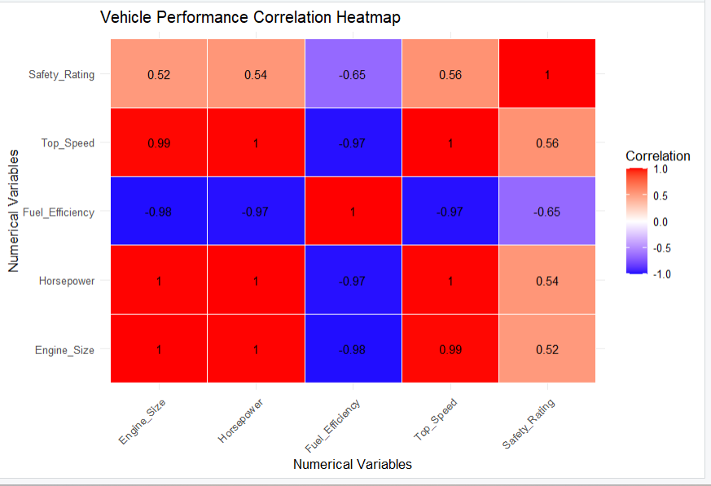
Result: Horsepower and engine size are strongly positively associated with top speed in these five observations. Fuel efficiency is negatively associated with horsepower and top speed. These are patterns in a small sample, not proof that one variable causes another.

Question 4: Vehicle Performance Dashboard
Procedure (Tableau)
- Import the Vehicle Performance dataset into Tableau.
- Create a bar chart with Vehicle_ID on Columns and Fuel_Efficiency on Rows. Add Safety_Rating to Color.
- Create a scatter plot with Horsepower on Columns and Top_Speed on Rows. Add Engine_Size to Color and Vehicle_ID to Detail.
- Drag Engine_Size and Safety_Rating to Filters and select Show Filter.
- Add Fuel_Efficiency, Horsepower, Top_Speed, and Safety_Rating to Tooltip.
- Create a dashboard titled Vehicle Performance Analysis Dashboard and place both charts and filters on it.

Output:
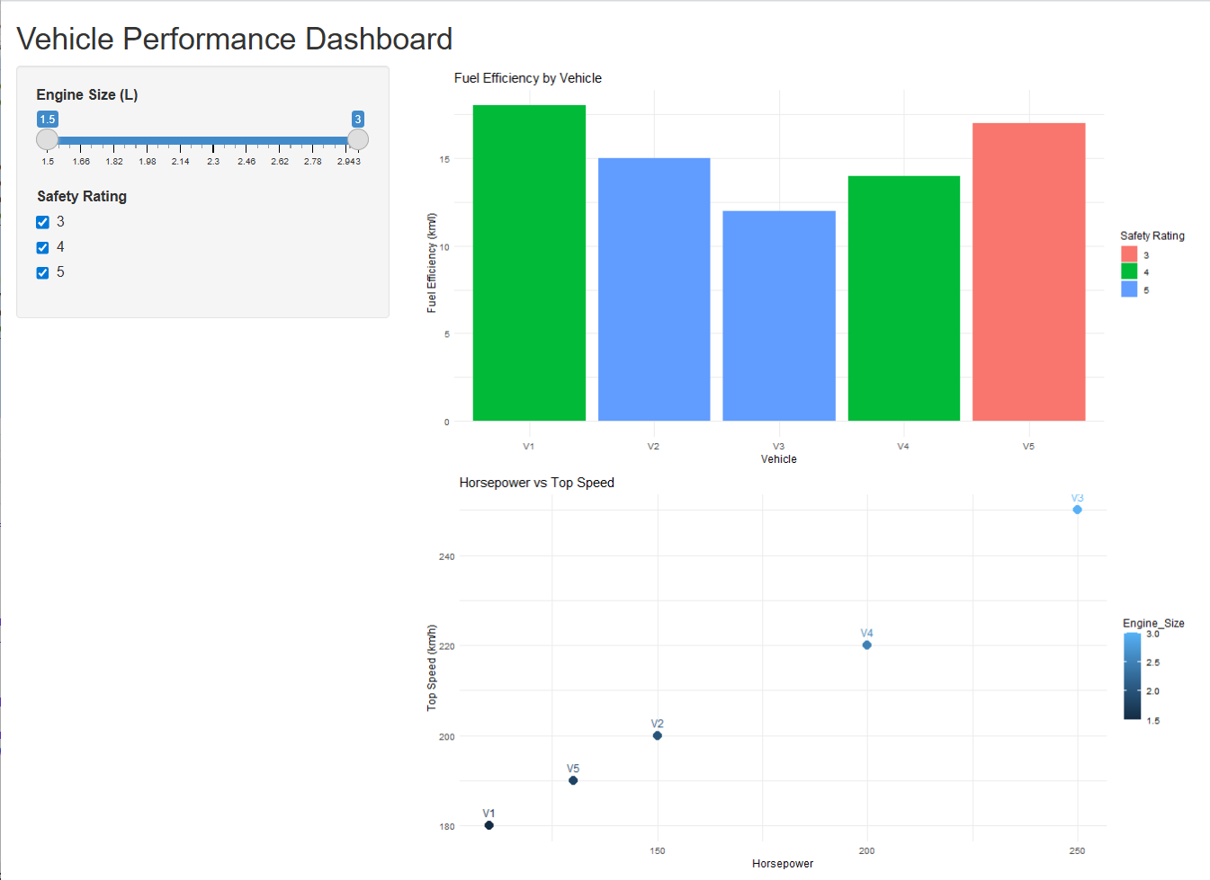

Result: One dashboard displays fuel efficiency and horsepower versus top speed. Users can filter engine size and safety rating to compare vehicles.

